**Surampudi Venkata Ganesh Swamy Narayana**

End to End use case example: ‐

Open NPU web page, go through the main home page ‐

Open Admissions to check some quick links ‐

Open Academics to learn more details ‐

Open Campus and go through NPU Campus tour ‐

Check more information (e.g. News and Blogs) ‐

Go to Online Application to register

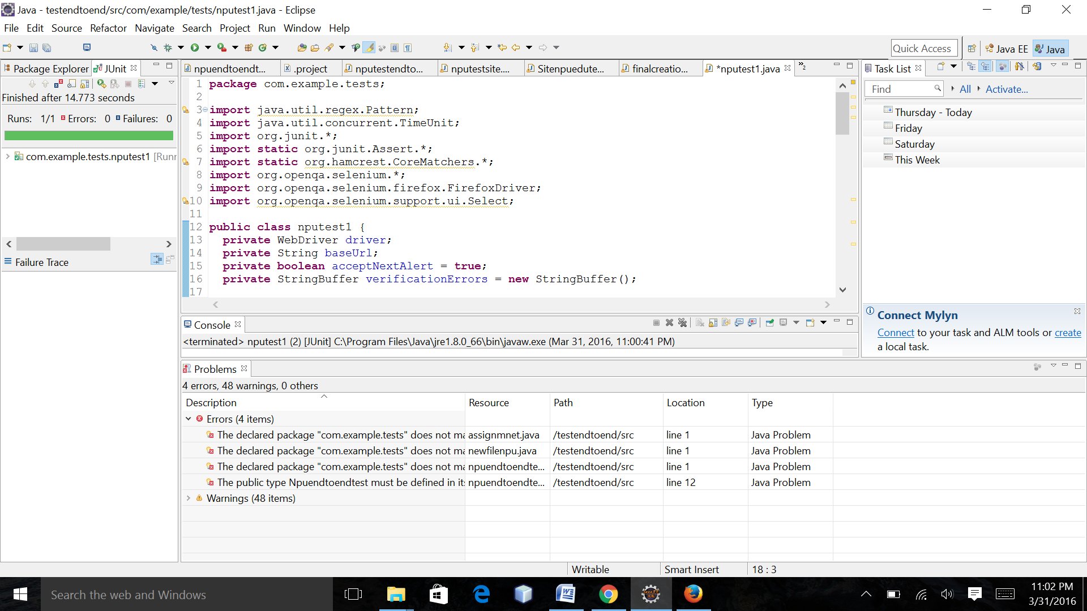

**package** com.example.tests;

**import** java.util.regex.Pattern;

**import** java.util.concurrent.TimeUnit;

**import** org.junit.*;

**import** **static** org.junit.Assert.*;

**import** **static** org.hamcrest.CoreMatchers.*;

**import** org.openqa.selenium.*;

**import** org.openqa.selenium.firefox.FirefoxDriver;

**import** org.openqa.selenium.support.ui.Select;

**public** **class** nputest1 {

**private** WebDriver driver;

**private** String baseUrl;

**private** **boolean** acceptNextAlert = **true**;

**private** StringBuffer verificationErrors = **new** StringBuffer();

@Before

**public** **void** setUp() **throws** Exception {

driver = **new** FirefoxDriver();

baseUrl = "https://www.google.com/";

driver.manage().timeouts().implicitlyWait(30, TimeUnit.SECONDS);

}

@Test

**public** **void** nputest1() **throws** Exception {

driver.get(baseUrl + "/#q=NPU+login");

driver.findElement(By.id("lst-ib")).clear();

driver.findElement(By.id("lst-ib")).sendKeys("NPU");

driver.findElement(By.linkText("Northwestern Polytechnic University")).click();

driver.findElement(By.linkText("Graduate Admission")).click();

driver.findElement(By.id("logo")).click();

driver.findElement(By.linkText("Scholarships")).click();

driver.findElement(By.linkText("Career Center Blog")).click();

driver.findElement(By.linkText("Sports Facilities")).click();

driver.findElement(By.linkText("Friendship Schools")).click();

driver.findElement(By.linkText("Health Insurance")).click();

driver.findElement(By.linkText("School of Engineering")).click();

driver.findElement(By.linkText("Student Life")).click();

driver.findElement(By.linkText("NPU News Home")).click();

}

@After

**public** **void** tearDown() **throws** Exception {

driver.quit();

String verificationErrorString = verificationErrors.toString();

**if** (!"".equals(verificationErrorString)) {

fail(verificationErrorString);

}

}

**private** **boolean** isElementPresent(By by) {

**try** {

driver.findElement(by);

**return** **true**;

} **catch** (NoSuchElementException e) {

**return** **false**;

}

}

**private** **boolean** isAlertPresent() {

**try** {

driver.switchTo().alert();

**return** **true**;

} **catch** (NoAlertPresentException e) {

**return** **false**;

}

}

**private** String closeAlertAndGetItsText() {

**try** {

Alert alert = driver.switchTo().alert();

String alertText = alert.getText();

**if** (acceptNextAlert) {

alert.accept();

} **else** {

alert.dismiss();

}

**return** alertText;

} **finally** {

acceptNextAlert = **true**;

}

}

}

